1. **MFA-Creation**
2. **Create Private and Public Subnet**
3. **Nat Instance and Nat Gateway**
4. **Install MySql**
5. **Install PhpMyAdmin**
6. **Access DB From Web**
7. **AutoScaling**
8. **Intro to RDS**

**Create a VPC with Private and Public Subnets**

1. In the top-right corner of the AWS Management Console, choose the region to create your VPC in. This example uses the US West (Oregon) region.
2. Select VPC from Services
3. Select Create VPC

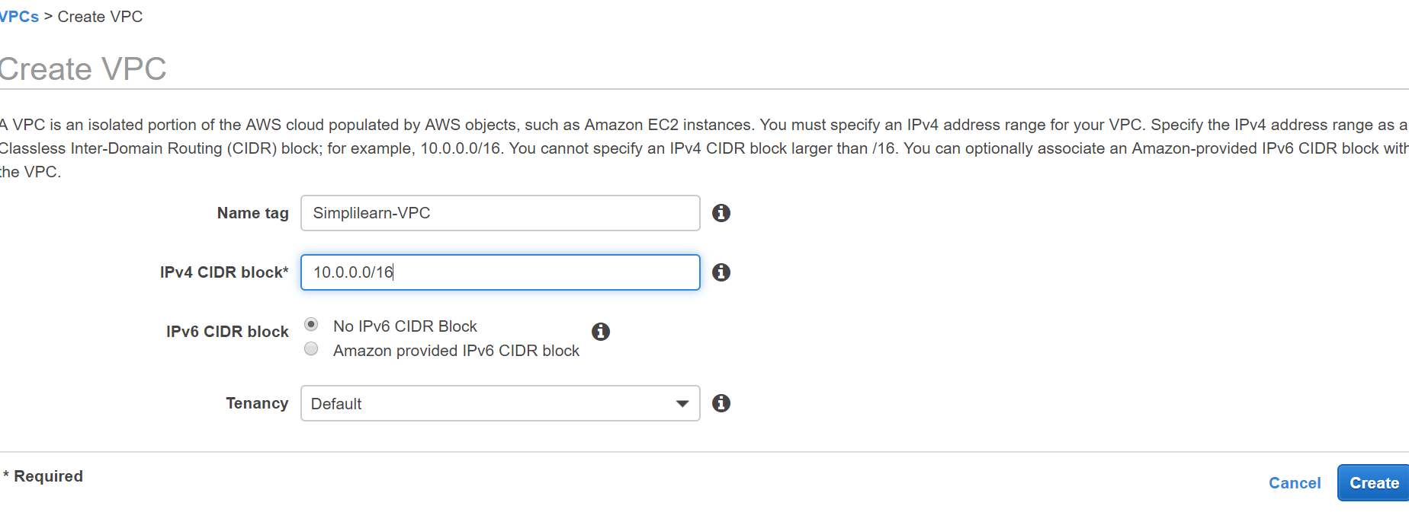

Create Public Subnet

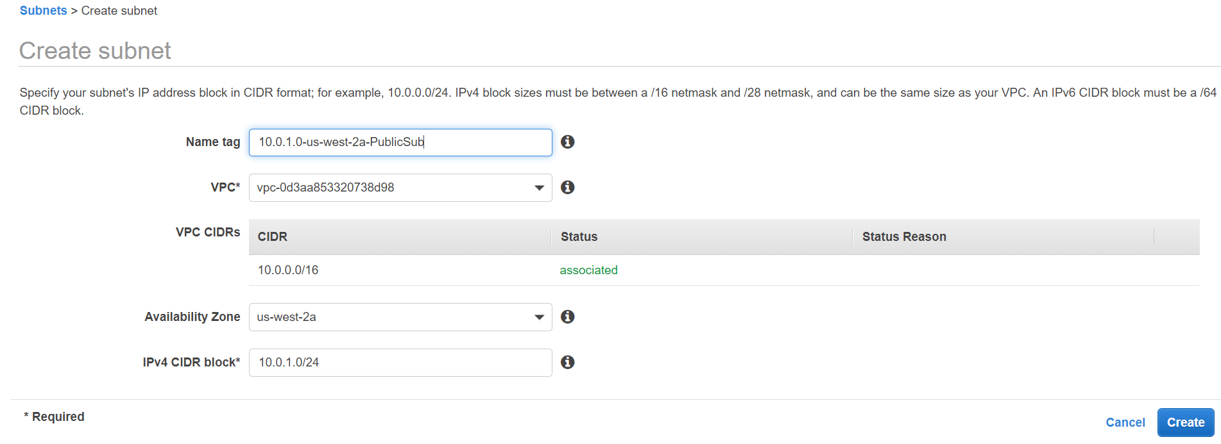

Create Private Subnet

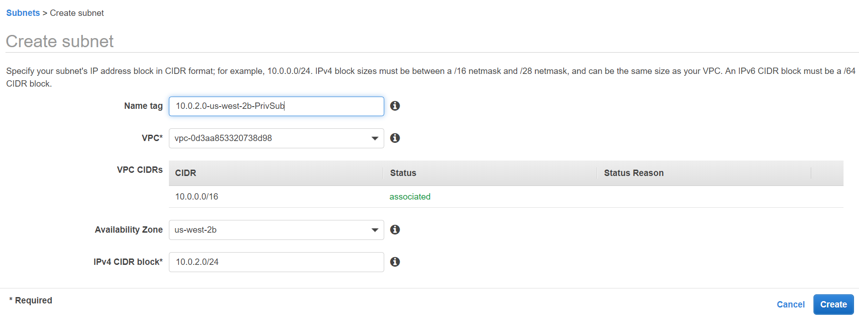

Create Internet Gateway

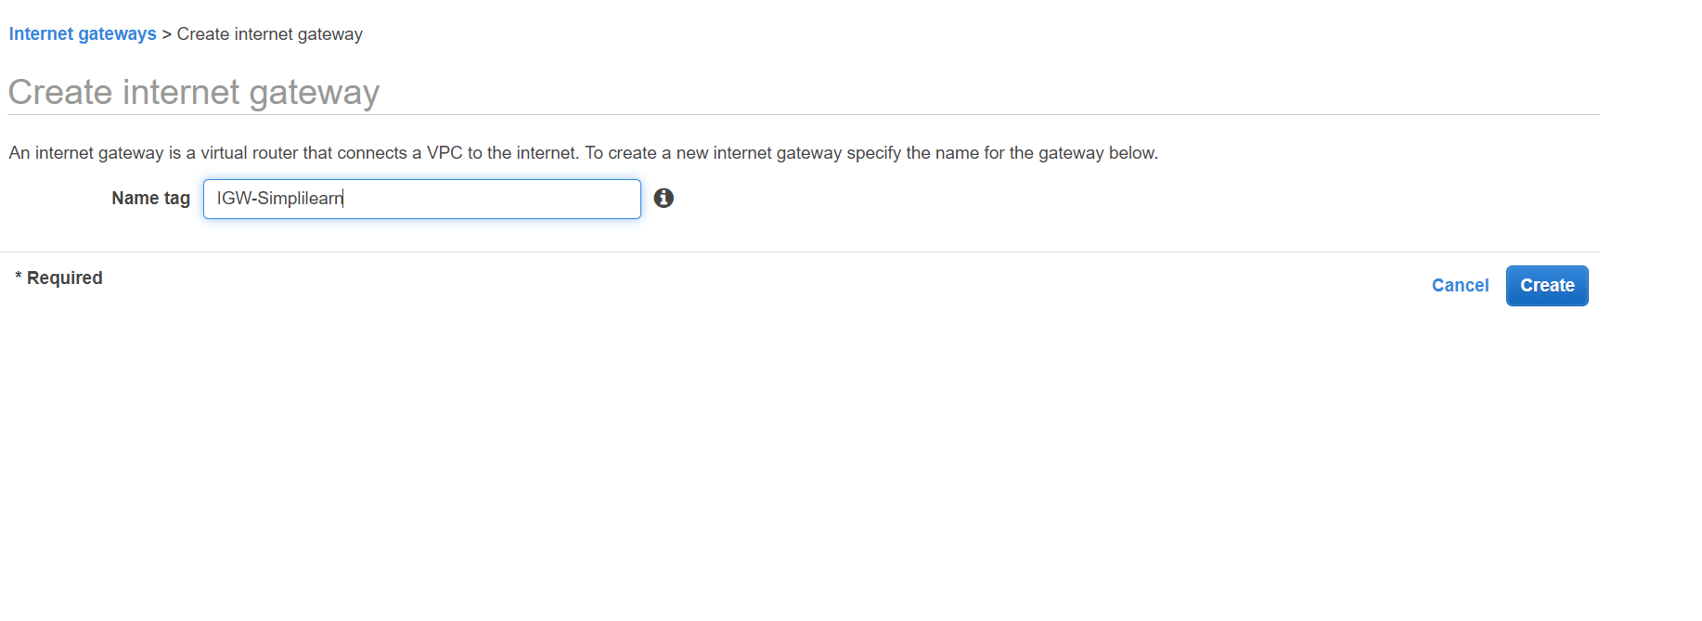

Attach IGW to a VPC

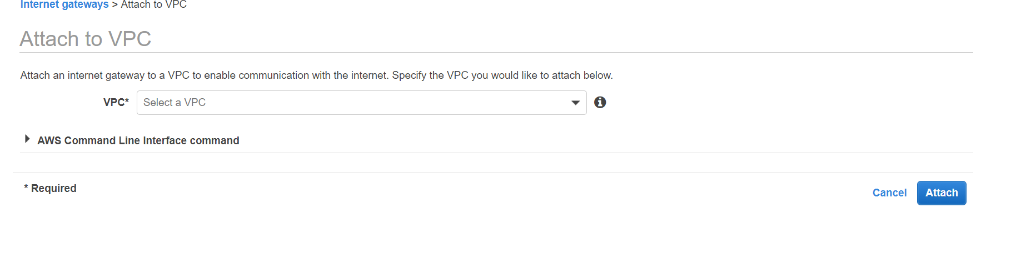

Create Route Table for Public Subnet

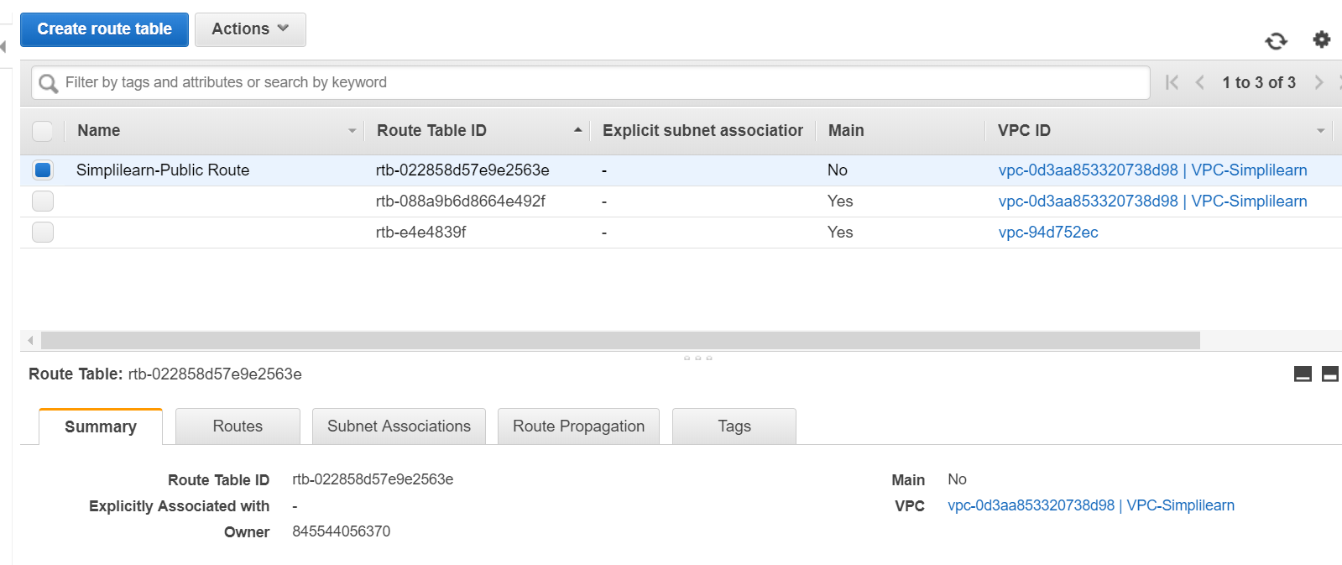

Associate Public Subnet to Route Table

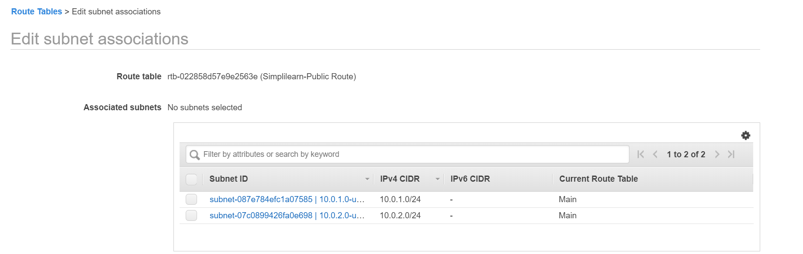

Create Route for Public Subnet to IGW

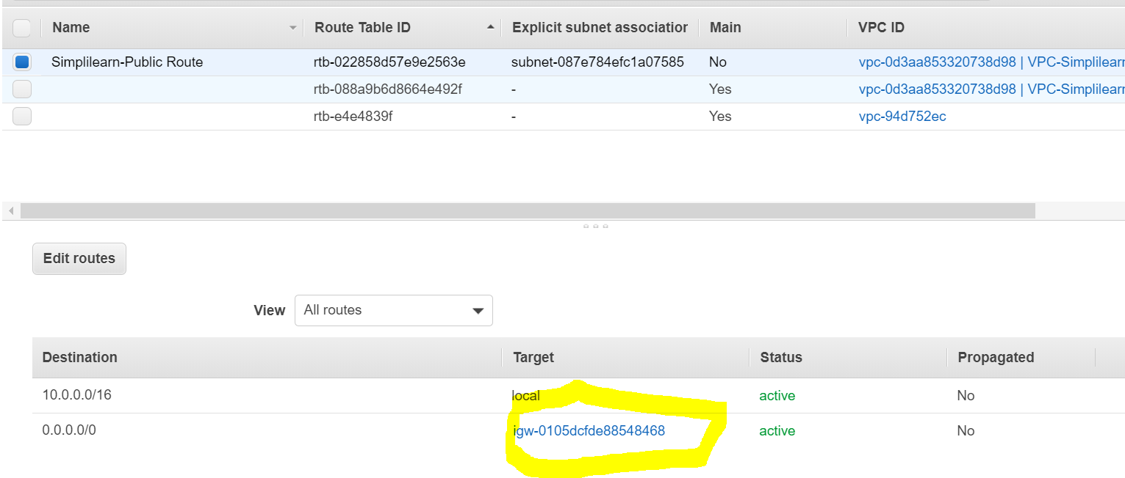

Create Route for Private Subnet

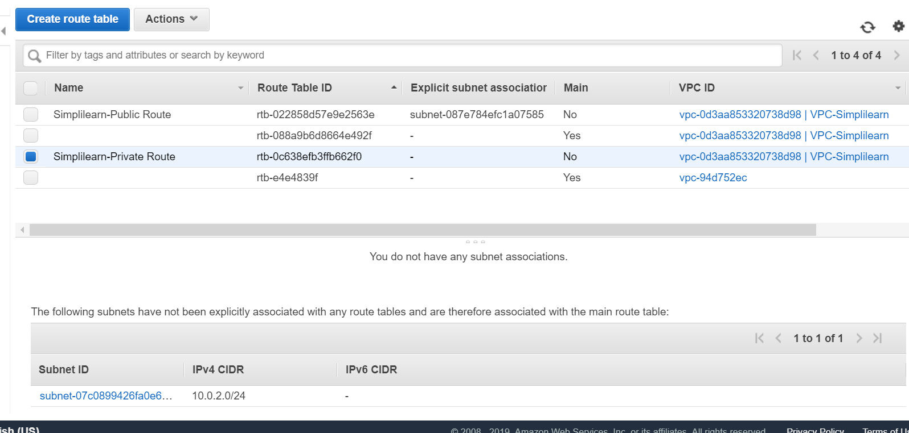

Associate Subnet to Route Table

## Create a VPC Security Group for a Public Web Server

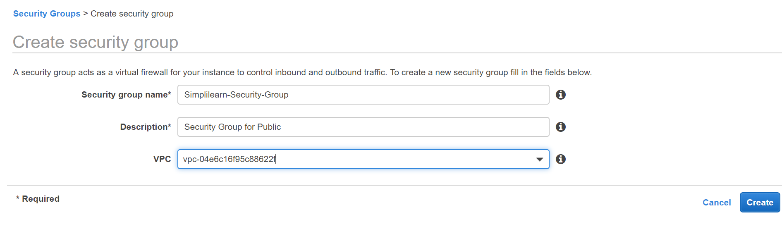

**add inbound rules to the security group**

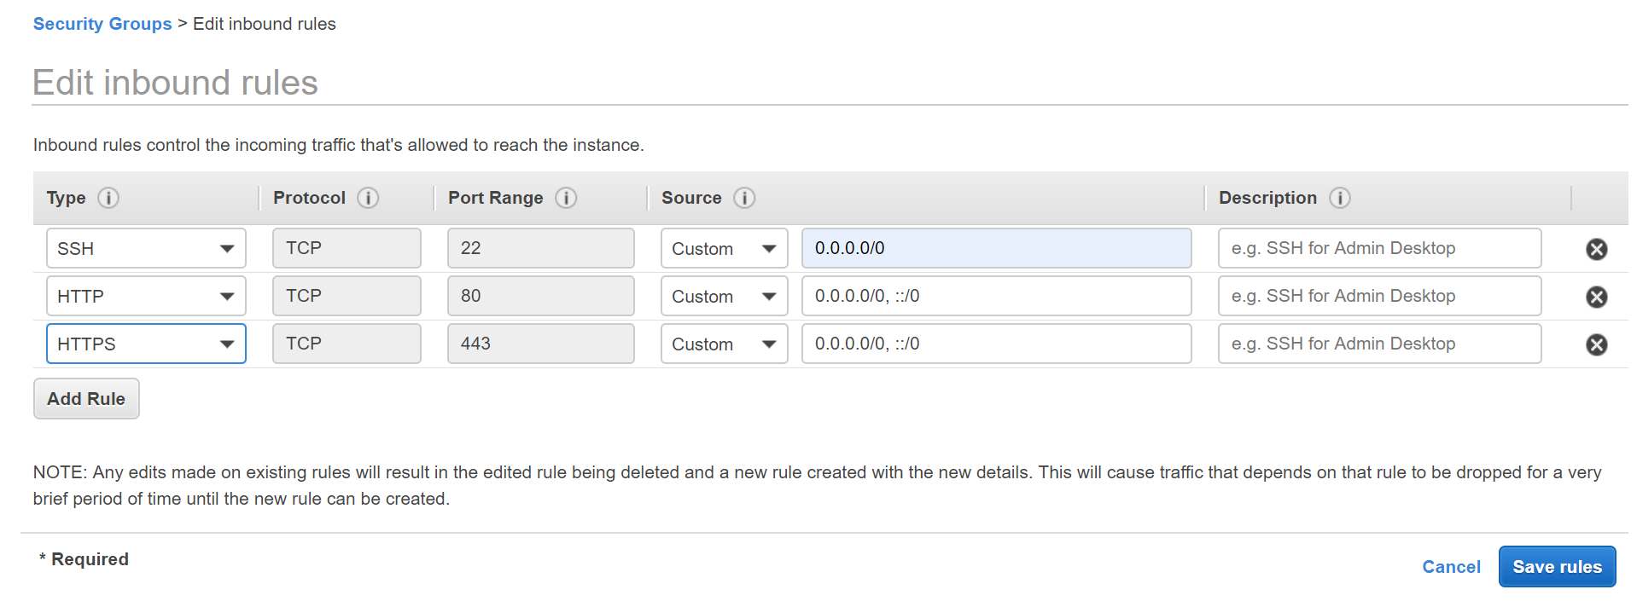

## Create a VPC Security Group for the Private Subnet

To keep your DB instance private, create a security group for private access. To connect to private instances in your VPC, you add inbound rules to your VPC security group that allow traffic from your web server only.

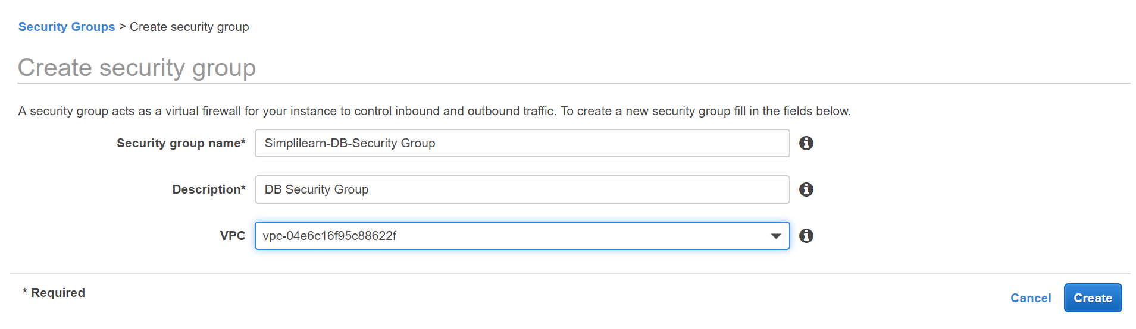

**add inbound rules to the security group**

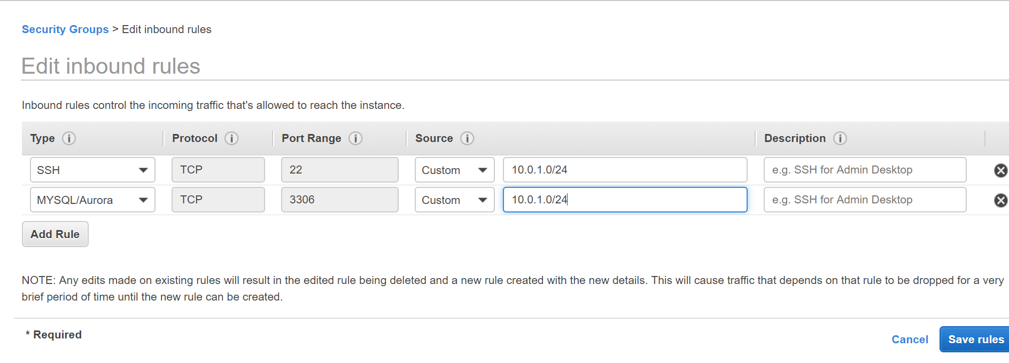

Launch Instance in Public Subnet

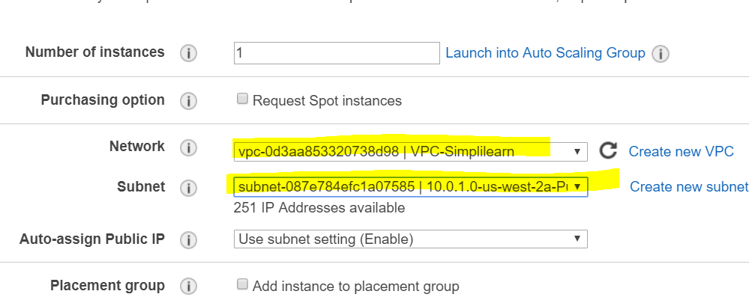

Launch instance in Private Subnet

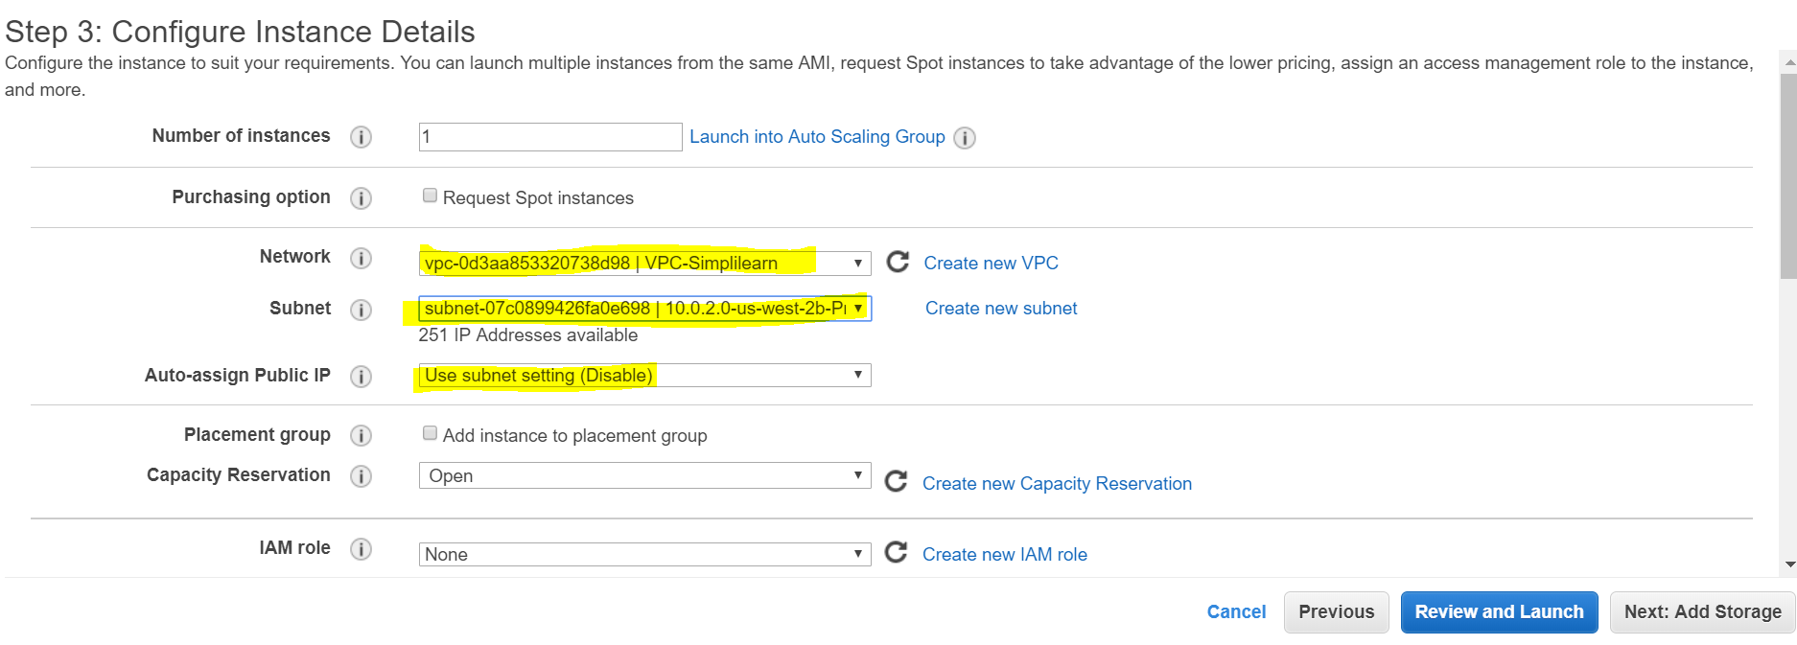

NAT Instance /NAT Gateway

You can use a network address translation (NAT) instance in a public subnet in your VPC to enable instances in the private subnet to initiate outbound IPv4 traffic to the Internet or other AWS services, but prevent the instances from receiving inbound traffic initiated by someone on the Internet.

<https://docs.aws.amazon.com/vpc/latest/userguide/VPC_NAT_Instance.html>

Imp:

## Disabling Source/Destination Checks

Each EC2 instance performs source/destination checks by default. This means that the instance must be the source or destination of any traffic it sends or receives. However, a NAT instance must be able to send and receive traffic when the source or destination is not itself. Therefore, you must disable source/destination checks on the NAT instance.

Comparison of Nat Instance vs Nat Gateway

<https://docs.aws.amazon.com/vpc/latest/userguide/vpc-nat-comparison.html>

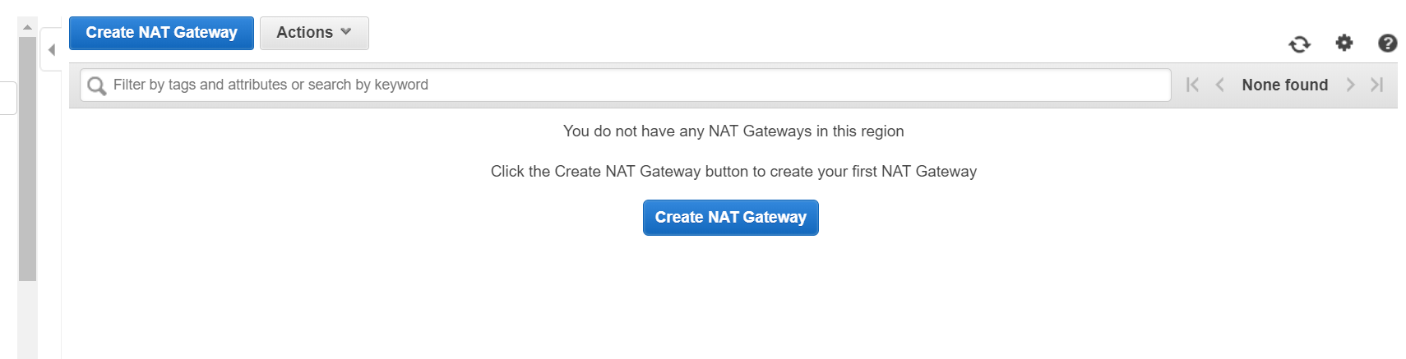

Create Route from Private Subnet to Nat Gateway

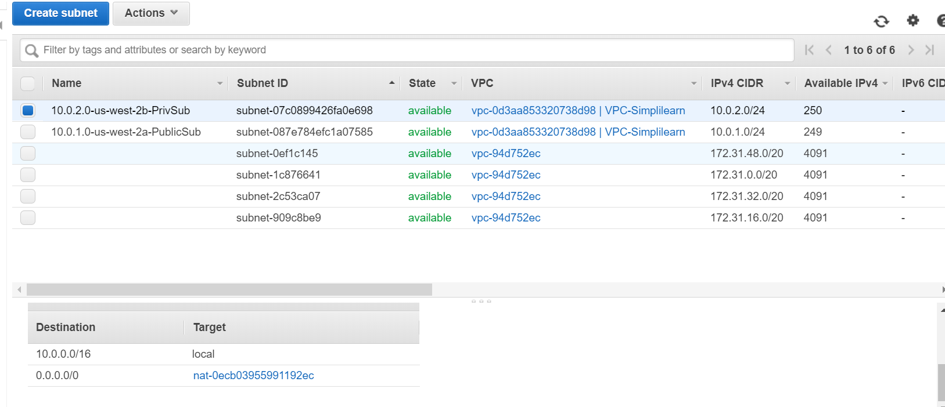

Install MySql Database on Instance in Private Subnet

Install MySql

wget <https://dev.mysql.com/get/mysql57-community-release-el7-11.noarch.rpm>

yum localinstall mysql57-community-release-el7-11.noarch.rpm

yum install mysql-community-server

systemctl start mysqld.service

[root@ip-10-0-2-178 ~]# mysql -u root -p

Enter password:

Welcome to the MySQL monitor. Commands end with ; or \g.

Your MySQL connection id is 2

Server version: 5.7.27

Copyright (c) 2000, 2019, Oracle and/or its affiliates. All rights reserved.

Oracle is a registered trademark of Oracle Corporation and/or its

affiliates. Other names may be trademarks of their respective

owners.

Type 'help;' or '\h' for help. Type '\c' to clear the current input statement.

mysql>

Secure your database:  
**mysql_secure_installation**

Answer the wizard questions as follows:

1. Enter current password for root: Press return for none
2. Change Root Password: Y
3. New Password: Enter your new password
4. Remove anonymous user: Y
5. Disallow root login remotely: Y
6. Remove test database and access to it: Y

Reload privilege tables now: Y

Create a new USER;

CREATE USER 'SAMC' IDENTIFIED BY 'Winter123#';

GRANT ALL PRIVILEGES ON *.* TO SAMC WITH GRANT OPTION;

On Instance in Public Subnet

Install Apache

Install PHP

CD /VAR/WWW/HTML

Install phpMyAdmin

**wget** [***https://www.phpmyadmin.net/downloads/phpMyAdmin-latest-all-languages.tar.gz***](https://www.phpmyadmin.net/downloads/phpMyAdmin-latest-all-languages.tar.gz)

**mkdir phpMyAdmin && tar -xvzf *phpMyAdmin-latest-all-languages.tar.gz* -C phpMyAdmin --strip-components 1**

rm *phpMyAdmin-latest-all-languages.tar.gz*

<http://34.211.170.164/phpMyAdmin/>

*cd phpMyAdmin*

*cp config.sample.inc.php config.inc.php*

*vi config.inc.php*

*Add the following to the end of the file*

